Automated Detection and Classification of Sleep Spindles using Machine Learning and Signal Processing Techniques

Abstract
This research focuses on the significance of sleep spindles in crucial cognitive processes such as memory consolidation, emotional regulation, and long-term memory reinforcement. Sleep spindles, which are thalamo-cortical oscillations, serve as key indicators of sleep quality and cognitive functioning. Using MATLAB's advanced signal processing capabilities, including techniques like bandpass filtering, short-time Fourier transform (STFT), and wavelet transformations, this study aims to accurately detect and classify sleep spindles from Electromyography (EMG) data.
To achieve automated spindle detection, several machine learning algorithms such as Support Vector Machines (SVM), K-Nearest Neighbors (KNN), and Convolutional Neural Networks (CNN) are employed and compared. Performance metrics such as precision, accuracy, and F1-scores are used to evaluate the effectiveness of each model.
The findings have important implications for both sleep science and the development of wearable technologies, offering potential advancements in real-time monitoring and personalized sleep health interventions.

Introduction
Sleep spindles are critical markers of sleep quality and play a key role in various cognitive functions, including memory consolidation, learning, emotional regulation, and long-term memory reinforcement. These spindle activities, which are thalamo-cortical oscillations, appear in the electroencephalogram (EEG) as sinusoidal wave patterns. Research shows that disturbances in spindle activity are linked to several disorders, such as schizophrenia and thalamic strokes, highlighting their importance in both sleep health and cognitive well-being.
Despite their significance, the automated detection and classification of sleep spindles from raw physiological data remain challenging. Traditional methods such as manual annotation are time-consuming and prone to human error. As a result, there is a growing need for more efficient, automated methods to identify these oscillations. Machine learning offers a promising solution by leveraging computational techniques to process large datasets, detect patterns, and classify spindles with greater accuracy and efficiency.
However, the current body of research has primarily focused on using conventional signal processing techniques, such as wavelet transforms and short-time Fourier transform (STFT), for spindle detection. Few studies have thoroughly explored how different machine learning algorithms perform in this context. There is a clear research gap in understanding which machine learning techniques—such as Support Vector Machines (SVM), K-Nearest Neighbors (KNN), or Convolutional Neural Networks (CNN)—are most effective for spindle detection and classification. This study aims to address this gap by conducting a comparative analysis of these algorithms, assessing their accuracy and potential for improving sleep spindle detection and cognitive research.

Literature Review
Sleep spindle detection has been a key focus of sleep research for decades, given its essential role in understanding cognitive functions such as memory consolidation and emotional regulation. Traditional methods for detecting spindles rely on signal processing techniques that examine brainwave data recorded through Electroencephalogram (EEG) or Electromyography (EMG). These methods are typically based on algorithms such as the Short-Time Fourier Transform (STFT), wavelet transforms, and various threshold-based techniques.
Signal Processing Techniques
One of the earliest methods for spindle detection was the Short-Time Fourier Transform (STFT), a time-frequency analysis tool used to identify spindle frequency ranges (typically between 11 Hz and 16 Hz). The STFT divides the signal into shorter segments and applies the Fourier transform to each segment, providing information on how the signal's frequency content changes over time. While effective, STFT's fixed time-resolution poses a challenge in detecting spindles with varying durations, as it often lacks the ability to capture transient signals accurately.
The wavelet transform has also been widely used for spindle detection. Unlike STFT, wavelet transforms allow variable time-frequency resolution, making it easier to detect short and non-stationary signals like sleep spindles. Wavelets decompose the signal into components at multiple scales, providing more flexibility in detecting spindles of different frequencies and durations. However, wavelet-based methods are still limited by the subjective choice of mother wavelets, which can lead to inconsistencies across different studies.
Threshold-based methods offer a simpler approach, where spindle detection is performed by setting specific thresholds for signal amplitude or power within the spindle frequency range. These thresholds are generally determined from prior knowledge or empirical analysis of EEG data. While threshold-based methods can be straightforward and computationally inexpensive, they often result in high false-positive rates, as spindles may overlap with other brain activity in terms of amplitude and frequency.
Limitations of Traditional Approaches
although these signal processing methods have laid the foundation for sleep spindle detection, they come with notable limitations. For example, traditional approaches often rely on manually set parameters, which can introduce bias or error. Spindles also exhibit variations in frequency, duration, and amplitude between individuals, making it difficult for fixed-parameter methods to generalize across different datasets or populations. Moreover, signal processing methods are often sensitive to noise and artifacts present in physiological recordings, leading to inaccurate detections.
Manual annotation of spindles, another commonly used approach, is labor-intensive and prone to human error. This has spurred interest in more automated and scalable solutions, particularly those involving machine learning, which can process large datasets with minimal manual intervention.
The Potential of Machine Learning
Machine learning algorithms have emerged as a promising alternative to traditional methods for detecting and classifying sleep spindles. Machine learning models, such as Support Vector Machines (SVM), K-Nearest Neighbors (KNN), and Convolutional Neural Networks (CNN), can be trained on large datasets to identify patterns in physiological data that are associated with spindles. These algorithms offer several advantages, including the ability to handle complex, non-linear relationships within the data, which are often missed by conventional signal processing techniques.
For example, SVM is a supervised learning algorithm that can effectively classify spindles by finding a hyperplane that best separates spindle data points from non-spindle data points. The flexibility of SVM in handling multi-dimensional feature spaces makes it highly suitable for spindle classification when combined with features like frequency, duration, and power spectral density.
KNN, on the other hand, is a simple yet effective algorithm that classifies spindle events based on their similarity to neighboring data points. Its ease of implementation and ability to adapt to new data make it useful in spindle detection, especially when the relationship between spindle characteristics is non-linear.
More advanced techniques like CNNs leverage deep learning models to automatically extract features from raw EEG data. CNNs are particularly powerful because they do not require manual feature extraction, allowing them to learn relevant patterns directly from the data. By using convolutional layers to capture spatial and temporal relationships in the signal, CNNs can provide highly accurate spindle detection results, outperforming traditional methods in several studies.
Machine learning techniques also offer the potential to improve generalizability across different datasets and populations. By training models on diverse data, machine learning approaches can adapt to individual variations in spindle characteristics, which is a limitation in traditional methods that rely on fixed thresholds or hand-tuned parameters. Moreover, these models can be further fine-tuned to detect spindles under different conditions, such as varying sleep stages or pathological states (e.g., schizophrenia or stroke), where spindle activity may be altered.
Comparative Studies
few studies have compared the performance of these machine learning algorithms in spindle detection and classification. However, initial findings suggest that machine learning models often outperform conventional methods in terms of accuracy, precision, and sensitivity. For example, a study comparing SVM and wavelet-based methods found that the machine learning approach reduced false-positive rates and improved the detection of low-amplitude spindles. Similarly, deep learning approaches like CNNs have demonstrated their ability to automatically identify complex patterns in raw EEG data, making them particularly promising for future research in this area.
Despite the growing interest in machine learning applications for spindle detection, there remains a gap in research that thoroughly compares different algorithms. Most studies focus on a single method, making it difficult to determine which machine learning techniques are most effective across various datasets and experimental conditions. The present research aims to fill this gap by evaluating and comparing multiple machine learning algorithms to determine the most efficient and accurate approach for sleep spindle detection and classification.
In summary, while traditional signal processing methods have played a crucial role in spindle detection, machine learning offers a path forward, providing enhanced automation, scalability, and accuracy. By systematically comparing various machine learning techniques, this study seeks to advance the field of spindle research and contribute to better understanding sleep’s role in cognitive processes.

Methods

Data Source
The data used in this study comes from raw Electromyography (EMG) recordings, which measure muscle activity and brain responses during sleep. Unlike more invasive techniques like EEG, EMG is a less intrusive option, making it ideal for continuous, real-time monitoring of sleep patterns. EMG data captures physiological signals, providing a rich dataset for spindle detection and analysis.

Signal Processing Techniques
- Bandpass Filtering
Bandpass filtering is applied to isolate the spindle frequency range (11-16 Hz) from the raw EMG data. By removing noise and unrelated frequency components, this filter ensures that only the spindle-relevant frequencies are retained for further analysis.
- STFT and Wavelet Transformations
The Short-Time Fourier Transform (STFT) is used to provide a time-frequency representation of the spindle signals, which is particularly helpful for identifying spindle events over short time intervals.
Additionally, wavelet transforms allow the data to be analyzed at multiple scales, which helps in extracting spindle characteristics such as frequency, amplitude, duration, and power spectral density (PSD). These features are critical for the subsequent classification steps in the study.

Machine Learning Algorithms
- Support Vector Machines (SVM)
SVM is a supervised learning algorithm that constructs a hyperplane in a high-dimensional space to classify spindle and non-spindle events. SVM is particularly effective when there is a clear margin of separation between classes, making it ideal for this binary classification problem.
- K-Nearest Neighbors (KNN)
KNN is a simple, non-parametric method that classifies a new data point based on the majority label among its nearest neighbors. KNN is particularly useful when the relationship between spindle features is non-linear, and it adapts well to diverse datasets.
- Convolutional Neural Networks (CNN)
CNN is a deep learning model that automatically learns and extracts relevant features from raw data. In this study, CNN is used to process the EMG data and detect spindles by learning complex patterns in the data without the need for manual feature extraction. CNN is especially advantageous for large datasets, as it can uncover intricate patterns that traditional models might miss.

Cross-Validation
To ensure the generalizability of the models, k-fold cross-validation is employed. This involves splitting the dataset into k subsets, where each subset is used as a validation set once, while the remaining subsets are used for training the model. This method helps reduce overfitting and provides a more accurate assessment of each model’s performance. Performance metrics such as accuracy, precision, recall, and F1-score are calculated during cross-validation to compare the models.
By applying these methods, the study aims to determine the most effective machine learning technique for detecting sleep spindles from EMG data, potentially advancing both sleep science and wearable technology for personalized sleep health monitoring.
Implementation:
This project utilizes the multitaper spectral analysis method, as described in the paper.The multitaper method, initially developed by David Thomson in the 1980s, is recognized for its superior statistical properties compared to single-taper spectral estimates.
The core principle of multitaper spectral estimation involves averaging multiple independent spectra derived from a single segment of data. Unlike single-taper methods, this technique employs multiple taper functions known as Discrete Prolate Spheroidal Sequences (DPSS). These functions are uncorrelated with one another, allowing for their spectra to be combined as if derived from independent trials. This reduces the variance typically observed in periodogram and single-taper methods, yielding more robust and reliable spectral estimates.
In the context of sleep spindle analysis, multitaper spectral estimation offers enhanced precision in identifying and characterizing the frequency components of spindle activity. By leveraging this method, we aim to achieve more accurate classification and detection of sleep spindles, providing valuable insights into their neurophysiological and cognitive implications.
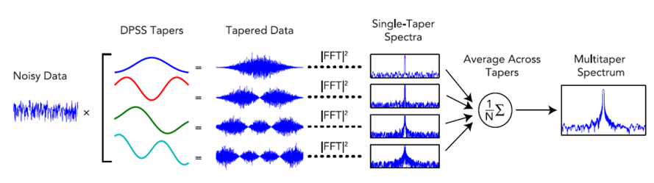

Usage:
multitaper_spectrogram_R.R utlizies R apply functions, contains no for loops, and includes optional multiprocessing, making it a fairly fast implementation of the multitaper spectrogram analysis.
Code:
results = multitaper_spectrogram_R(data, fs, frequency_range, time_bandwidth, num_tapers, window_params, min_nfft, weighting, detrend_opt, parallel, num_workers,
plot_on, verbose, xyflip)
spect = results[[1]]
stimes = results[[2]]
sfreqs = results[[3]]

Example: Chirp Data and Multitaper Spectrogram Analysis
In this example, we simulate chirp data and compute its multitaper spectrogram:
- Generate Chirp Data:
Chirp signals are commonly used in signal processing to test spectral estimation methods. We generate a signal whose frequency increases linearly over time.
- Apply Multitaper Spectrogram Analysis:
Using the multitaper method, we analyze the signal's time-frequency characteristics. This approach reduces spectral variance and provides a clearer visualization of the chirp's frequency modulation.

install.packages("signal")
library(signal) # get signal library for chirp function

# Set spectrogram params
fs = 200 # Sampling Frequency
frequency_range = c(0, 25) # Limit frequencies from 0 to 25 Hz
time_bandwidth = 3 # Set time-half bandwidth
num_tapers = 5 # Set number of tapers (optimal is time_bandwidth*2 - 1)
window_params = c(4, 1) # Window size is 4s with step size of 1s
min_nfft = 0 # No minimum nfft
weighting = 'unity' # weight each taper at 1
detrend_opt = 'constant' # detrend each window by subtracting the average
parallel = TRUE # use multiprocessing
num_workers = 3 # use 3 cores in multiprocessing
plot_on = TRUE # plot spectrogram
verbose = TRUE # print extra info
xyflip = FALSE # do not transpose spect output matrix

# Generate sample chirp data
t = seq(1/fs, 600, by=1/fs) # Create 10 min time array from 1/fs to 600 stepping by 1/fs
f_start = 1 # Set chirp freq range min (Hz)
f_end = 20 # Set chirp freq range max (Hz)
data = chirp(t, f_start, tail(t,n=1), f_end, 'logarithmic')

# Compute the multitaper spectrogram
results = multitaper_spectrogram_R(data, fs, frequency_range, time_bandwidth, num_tapers, window_params, min_nfft, weighting, detrend_opt, parallel, num_workers,
plot_on, verbose, xyflip)
spect = results[[1]]
stimes = results[[2]]
sfreqs = results[[3]]

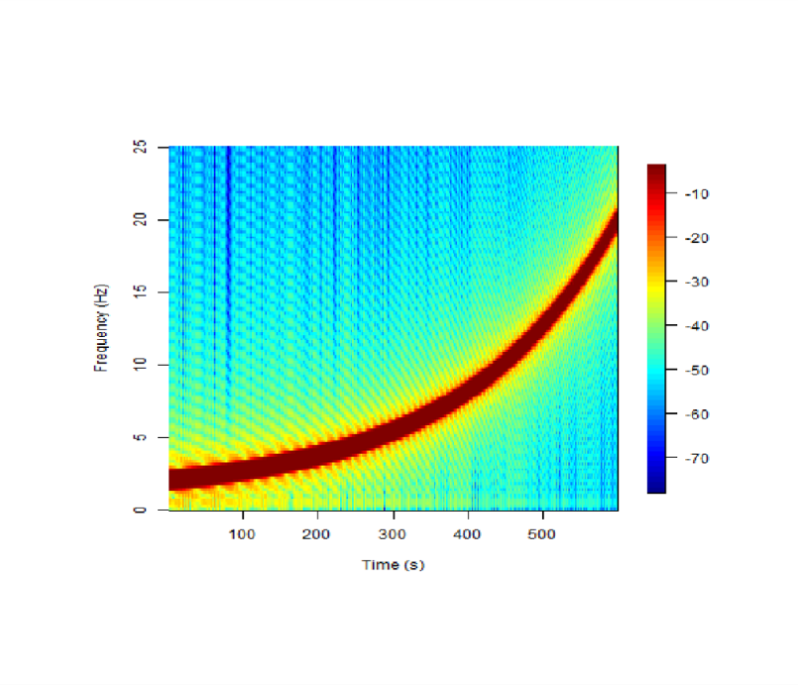

Steps to Enable Parallel Processing
- Install Necessary Libraries: Ensure parallel and doParallel libraries are installed.
- Set the Number of Workers: Define the number of cores to utilize using the num_workers argument.
- Handle Automatic Core Assignment: If no specific number is provided, use detectCores() to determine available cores and use all minus one to keep the system responsive.
- Optimize for System Type: Parallel processing performs best on Unix systems, so expect slower performance gains on Windows.
Code:
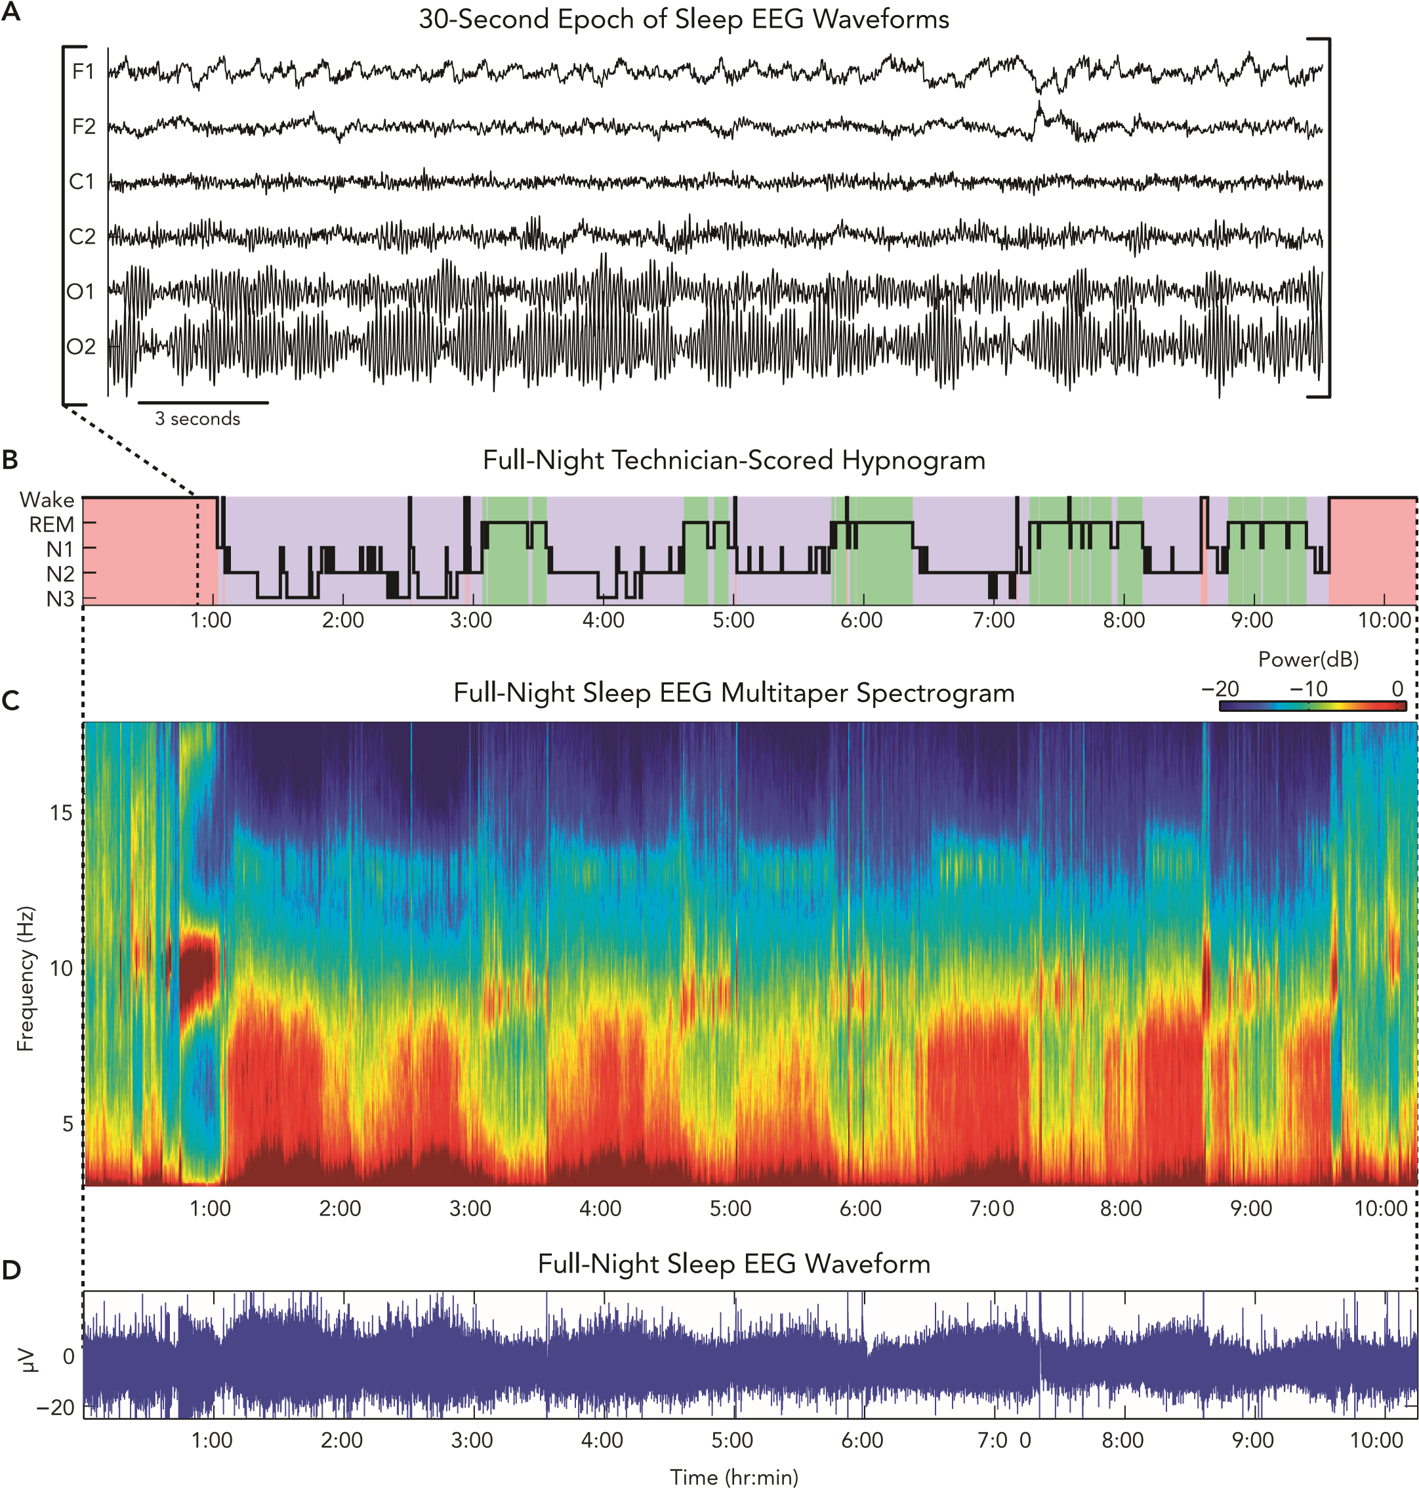
..\Desktop\code.txt

FIGURE 1. Dynamic spectral analysis of sleep EEG provides a data-rich, high-resolution characterization of neural activity that is more informative than traditional visual sleep staging

In clinical sleep polysomnography (PSG), EEG waveforms (A) from bilateral frontal (F1, F2), central (C1, C2), and occipital (O1, O2) electrodes are recorded along with other physiological signals. These signals are then visually scored by technicians who painstakingly categorize sleep into stages (wake, REM, stage N1–N3) in 30-s epochs, the progression of which is called a hypnogram (B). The multitaper sleep EEG spectrogram (C) takes only seconds to estimate and reveals patterns of oscillatory dynamics that correspond closely to the rough architecture of the hypnogram. The spectrogram shows spectral power (color: cool ¡ warm::low ¡ high power) as a function of time (x-axis) and frequency (y-axis). Furthermore, the multitaper spectrogram provides a visually striking characterization of the continuum of brain oscillatory activity during sleep, providing information that is lost in a typical hypnogram. Additionally, the multitaper sleep spectrogram can describe an entire night of sleep in a single visualization, whereas the EEG waveform trace of the same data (D) provides no detailed information at this scale.
and Kleitman (4, 30). This paved the way for the Rechtschaffen and Kales (R&K) system in 1968 (77), which classified sleep into 30-s epochs of Wake, REM, and four stages of non-REM (NREM). The use of 30-s epochs is a procedural relic from the 1930s, when Loomis et al. used a paper tape system to physically plot the EEG, which automatically cut the paper into 30-cm strips with the paper moving at 1 cm/s. Almost 50 years later, R&K scoring is still the clinical standard for sleep medicine and sleep research, with minor adjustments such as reducing NREM to three stages (N1–N3) (42). As such, sleep staging based on R&K scoring has long served as a useful tool and an essential foundation for numerous important advances in sleep research and in clinical sleep medicine.
The use of sleep staging, however, comes with several substantial drawbacks. In practice, sleep staging is a time-consuming process, requiring highly trained sleep technicians to visually categorize hours of waveform data in hundreds of nonoverlapping 30-s epochs. Sleep staging is also subjective, since the sleep stage within each epoch is determined by eye based on the technician’s interpretation of the waveform data and application of the staging rules. Consequently, achieving consistency between scorers is an ongoing concern. Even for sleep in healthy subjects, the average rate of disagreement between experienced technicians is !20%, and it can take several years for a technician to learn to score at this level of accuracy. In cases of pathological sleep, the interscorer variability increases even further, since the oscillatory activity does not fall neatly into the guidelines for one of the pre-defined sleep stages and thus cannot be adequately characterized by the hypnogram (36, 37, 83). Sleep staging is therefore also inflexible, in that a finite set of stage definitions is unlikely to support characterization of the vast heterogeneity in the sleep EEG observed in both healthy and clinical populations.
From a data analysis standpoint, sleep staging reduces the information-rich, dynamic, and continuous process of sleep to an abstract, low-resolution summary of discrete semantic states. Thus, no matter how sophisticated analysis techniques and scientific studies become, they will ultimately be limited if the results must always be referenced back to the framework of the hypnogram, which discretizes sleep in time and in state. Sleep staging discretizes sleep in time by defining the hypnogram in non-overlapping 30-s epochs, a length of time based on historical convention and practicality, rather than a principled analysis of sleep dynamics. By placing a temporal constraint upon the data, sleep staging imposes the assumption that sleep state cannot change any faster than every 30 s and that the neural activity within each epoch is not changing. This assumption reduces the ability to characterize sleep states that are shorter than 30 s, such as sleep microstates. Consequently, the analysis of transient EEG phenomena is either performed manually—such as periodic limb movements of sleep (PLMS), cortical EEG arousals—or remains un-quantified in clinical work (e.g., spindles, K-complexes, cyclic alternating pattern). Objective characterization of these brief events may prove clinically important to complement the extensive work on the disruptions associated with obstructive sleep apnea (OSA) and, perhaps to a lesser degree, PLMS. Sleep staging also discretizes sleep in state by restricting sleep states to only five possibilities (i.e., Wake, REM, NREM stage 1–3), making it impossible to represent sleep phenomena that vary along a continuum. Overall, the resolution in visual sleep staging is limited to the qualitative features in the EEG that can be practically discerned and categorized by the human eye. Attempts to improve staging by defining a greater number of stages over smaller epochs (39, 80) have not been adopted in the field, in part because these enhanced resolution sleep-staging paradigms are even more laborious than the current standard. Given the need to analyze brief changes in the EEG and to characterize a continuum of neural states, it is therefore important to have an objective, quantitative analysis of the EEG that minimizes subjectivity and the need for discretization.
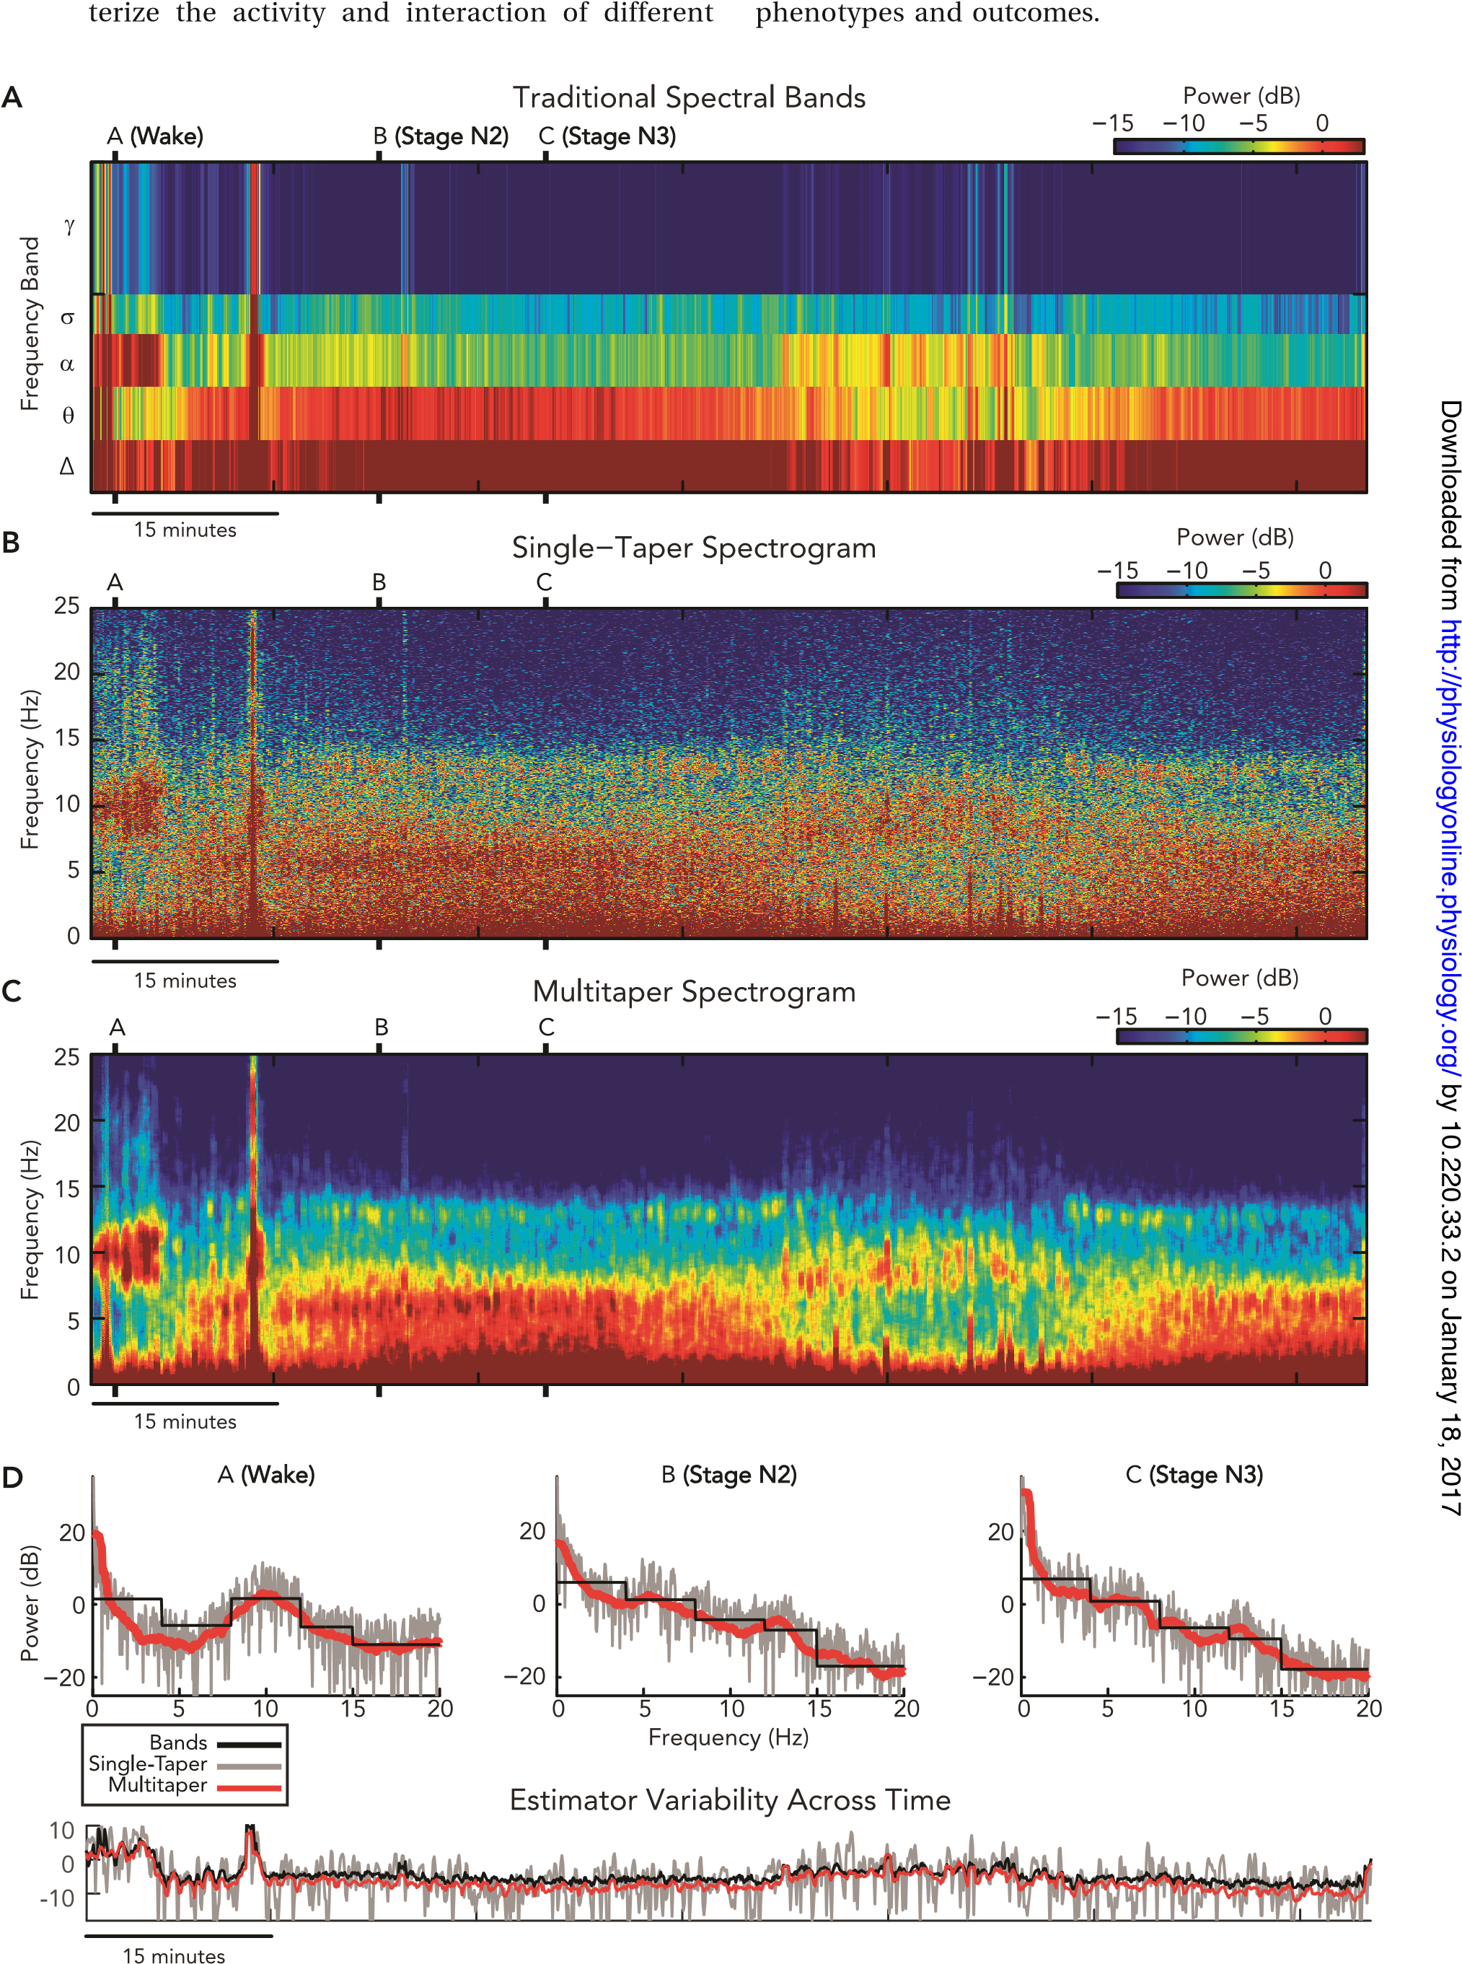

FIGURE 2. The multitaper method outperforms conventional spectral estimators, producing high-resolution EEG spectrograms with significantly reduced bias and variance
We estimated spectrograms from a single occipital EEG channel using periodogram-based frequency band averaging (A), single-taper Hanning window (B), and multitaper (C) approaches, each using 30-s windows spaced at 5-s intervals. In D, comparisons of spectra from each approach are shown using 30-s data windows from wake (marker A), NREM stage 2 (marker B), and NREM stage 3 (marker C) states. Below these spectra is a comparison of spectral power at 10 Hz for each method across time, illustrating differences in the temporal variability of each estimator. Traditional bands produce a low-resolution spectrogram (A) with coarse step-function spectra, but have low variability in power across time (D; black curves). Periodogram and single-taper spectrograms (B), while offering a high-frequency resolution, produce noisy spectra with ill-defined peaks and have a high temporal variability (D; gray curves). In contrast to these traditional approaches, the multitaper spectrogram (C) has a high-frequency resolution, shows clearly defined smooth oscillation peaks, and has low temporal variability (D; red curves).
data can produce estimates that differ greatly from the ideal spectrum, producing inaccurate results and potentially leading to false conclusions. To obtain more meaningful spectral estimates for real data, we use different strategies to address the false theoretical assumptions, each of which comes with special considerations and tradeoffs. For example, EEG data are never truly stationary, so it is common to analyze small time segments of an experiment within which the data properties are assumed to be unchanging. While stationarity improves as the segments of data become smaller, our ability to discern oscillations at closely spaced frequencies decreases. The spectral resolution is defined as the smallest difference in frequencies that we can resolve. Thus there is a tradeoff between data window length and stationarity on one hand and spectral resolution on the other. In the following sections, we will describe the methods used for spectral estimation for EEG data and their pitfalls, followed by techniques for improving spectral accuracy (bias and resolution) and clarity (variance).

The Periodogram: “An Extremely Poor Spectral Estimator”
The simplest and most common method used for performing spectral estimation on EEG data is called the periodogram. In practice, the computation of the periodogram involves an algorithm
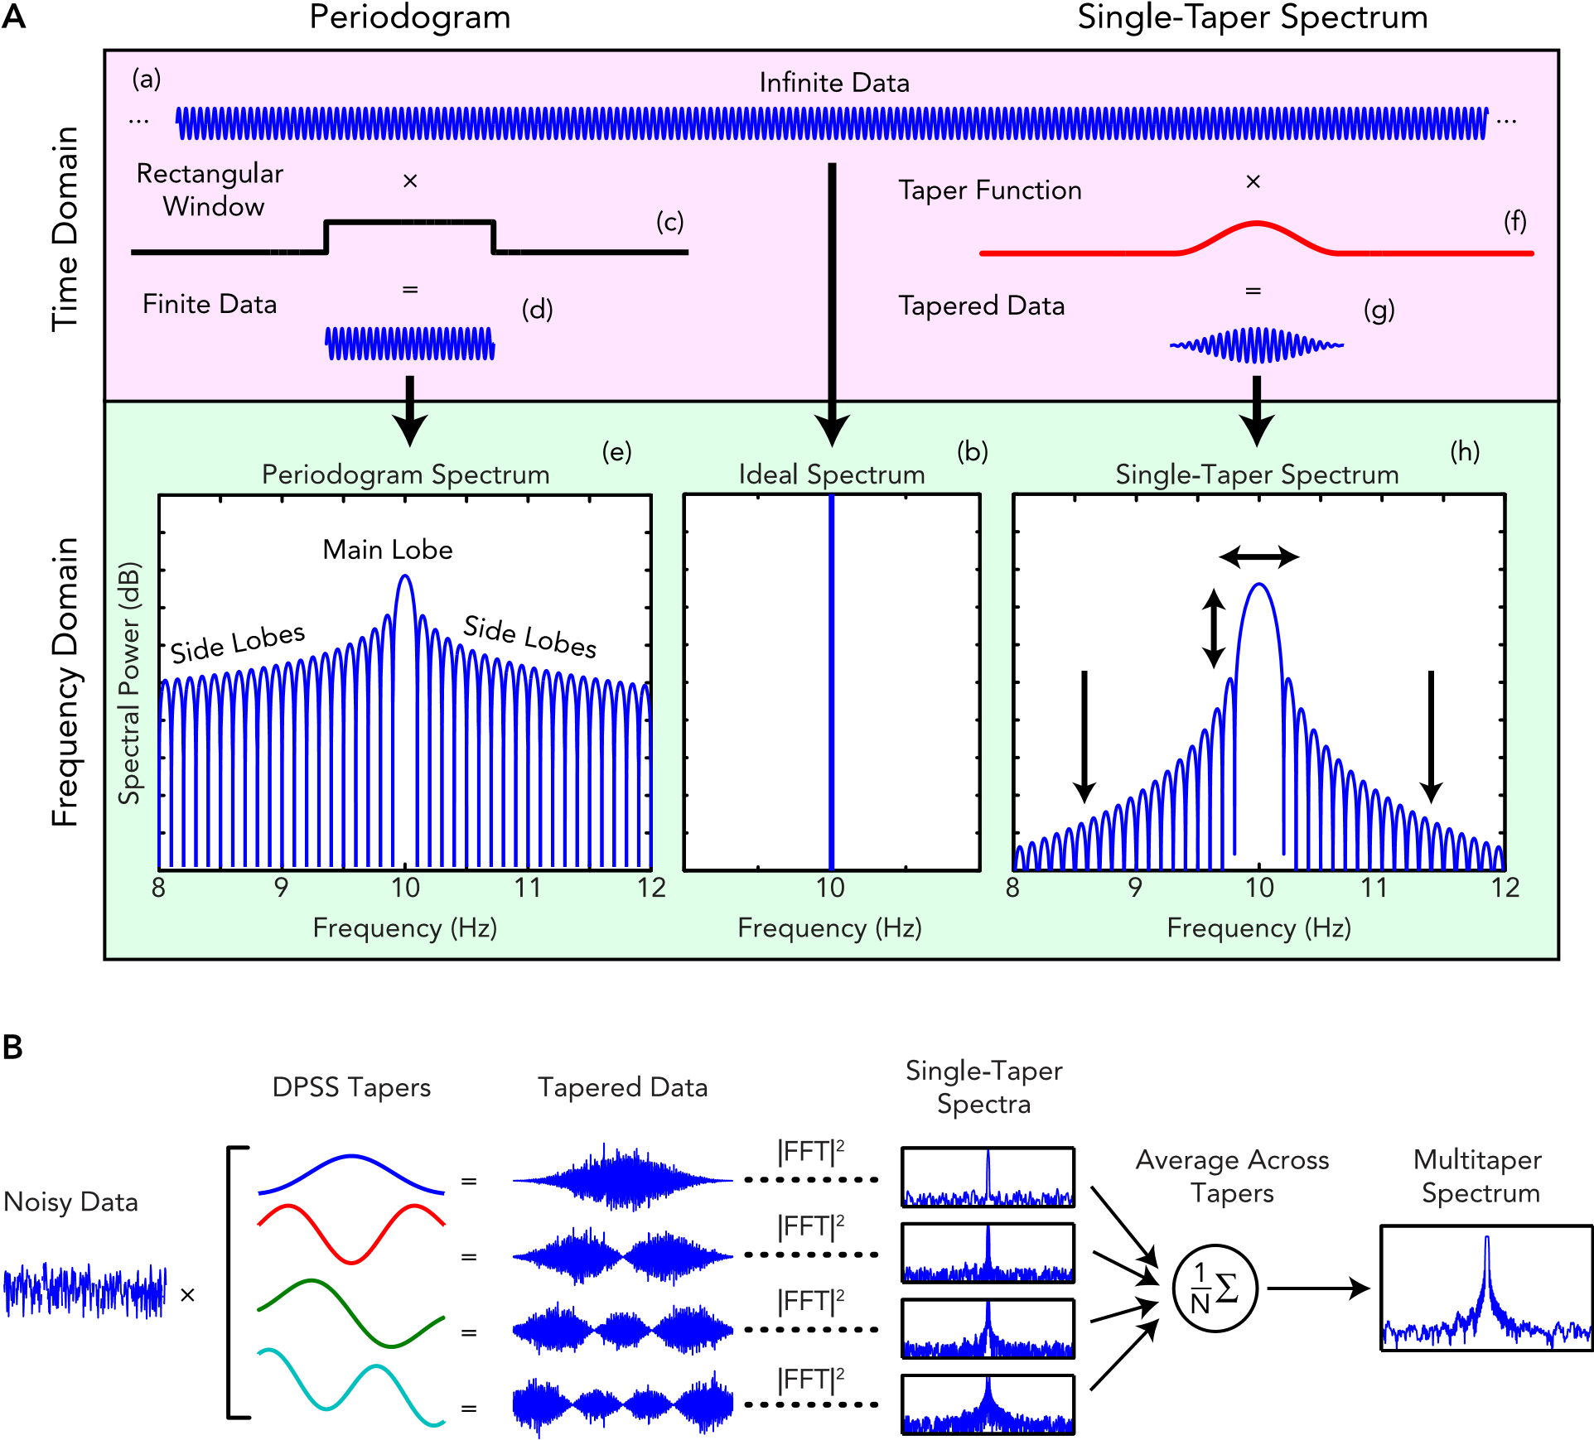
by 10.220.33.2 on January 18, 2017
/
http://physiologyonline.physiology.org

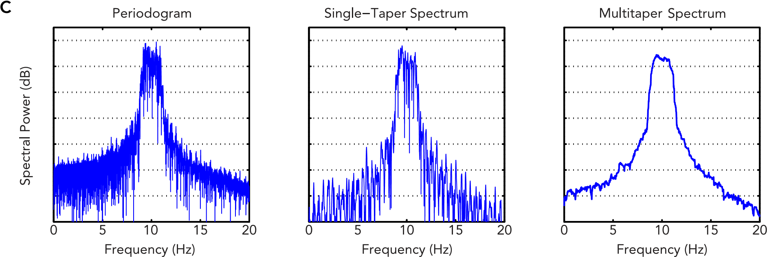

FIGURE 3. Multitaper spectral analysis reduces bias and variance in spectral estimation
A: an illustration of periodogram bias and the effects of tapering, using a 10-Hz sinusoid as an example. In theory, infinite data
(a) yields a theoretical ideal spectrum with widthless peaks at each frequency (b). In practice, the periodogram of finite data (d) is an inaccurate (biased) and noisy (variable) spectral estimator (e), with a multi-peaked structure caused by sharp discontinuities imposed by finite data (c). Tapering reduces bias by taking the product of the data and a “taper” function (f) that smooths the discontinuities at the data ends (g). In doing so, tapering reduces bias by lowering the power in the side lobes of the spectrum (h). B: a schematic of multitaper spectral estimation, which works by averaging multiple single-taper spectra that are computed using a special set of orthogonal functions. C: a comparison of spectral estimates for a simulated noisy EEG spectral peak. The multitaper spectrum shows a smooth peak with greatly reduced noise compared with periodogram and single-taper (Hanning window) estimates.

called the fast Fourier transform (FFT), which is an efficient implementation of the Fourier transform for data in discrete time. Unfortunately, the periodogram has several suboptimal properties that cause major problems in spectral estimation. In fact, in his textbook Spectral Analysis and Time Series (75), Priestly calls the periodogram “ !!! an extremely poor (if not a useless) estimate of the spectral density function.” However, while rarely appearing in any state-of the-art signal processing application, the periodogram (often incorrectly referred to as the “FFT”) is used widely and without reservation within the EEG literature.
What makes the periodogram such a poor estimator? When we compute the periodogram for a pure sinusoid in discrete time, instead of the single peak of the ideal spectrum, the periodogram estimate looks quite different. The resulting periodogram spectral estimate (FIGURE 4Ae) is comprised of a large rounded peak at the oscillation frequency, called the main lobe, flanked on both sides by a series of narrower peaks of decreasing power, called the side lobes. As we will soon see, the discrepancies between of the periodogram and the ideal spectrum can cause major problems for EEG data analysis, and must be dealt with effectively to achieve accurate results.
Why does the periodogram spectrum differ from the ideal spectrum? An intuitive way of conceptualizing this phenomenon is to think of any finite data series (FIGURE 4Ad) as the product of infinite data (FIGURE 4Aa) and a rectangular or boxcar window (FIGURE 4Ac), with a value of 1 for the duration of the data and 0 everywhere else. Consequently, the periodogram of any finite data is the combination (convolution) of the ideal data spectrum with the spectrum of the rectangular window, which is a multipeaked function with a main lobe and side lobes. The periodogram of a single, finite sinusoid is the rectangular window spectrum centered at the main oscillation frequency. Generalized to all finite data, the periodogram will be the rectangular window spectrum replicated at each of the peaks in the ideal data spectrum, scaled by the amplitude of each peak (69).
How do these differences between the periodogram and the ideal spectrum affect the data analysis? The presence of side and main lobe power means that the periodogram of finite data is a biased estimator of the spectrum; that is, the estimated periodogram spectrum for real data will differ from the ideal (expected) spectrogram, especially in cases where the data length is small. The side and main lobes in the periodogram allow noise at a given frequency to “leak” into the estimate at other frequencies, distorting the true spectral content of the data. This spectral leakage, as it is called, reduces the accuracy of the estimate and makes it more difficult to clearly distinguish peaks in the spectrum, especially in noisy data such as EEG.
The side and main lobes contribute to the periodogram bias in different ways. The side lobes introduce a broadband bias, which means noise across a broad range or band of frequencies is incorporated into the estimate. In our 10-Hz example, the ideal spectrum only has power at the central oscillation frequency. In contrast, the periodogram has side lobes that stretch out over all frequencies, falsely indicating the presence of broadband power. The power, which should be concentrated at a single frequency, is redistributed by the periodogram to frequencies where it does not belong. This broadband bias can be particularly problematic when data are noisy or have multiple closely spaced frequency peaks. In such cases, the side lobes in a periodogram act like transmitters, redistributing power from noise or multiple oscillations to unrelated frequencies. Thus, without taking measures to improve bias, an EEG periodogram can be easily corrupted by background noise, artifacts, and signals at frequencies unrelated to the oscillations being studied.
Example:
In this example we create some chirp data and run the multitaper spectrogram on it.
import numpy as np # import numpy
from scipy.signal import chirp # import chirp generation function
# Set spectrogram params
fs = 200 # Sampling Frequency
frequency_range = [0, 25] # Limit frequencies from 0 to 25 Hz
time_bandwidth = 3 # Set time-half bandwidth
num_tapers = 5 # Set number of tapers (optimal is time_bandwidth*2 - 1)
window_params = [4, 1] # Window size is 4s with step size of 1s
min_nfft = 0 # No minimum nfft
detrend_opt = 'constant' # detrend each window by subtracting the average
multiprocess = True # use multiprocessing
cpus = 3 # use 3 cores in multiprocessing
weighting = 'unity' # weight each taper at 1
plot_on = True # plot spectrogram
return_fig = False # do not return plotted spectrogram
clim_scale = False # don't auto-scale the colormap
verbose = True # print extra info
xyflip = False # do not transpose spect output matrix

# Generate sample chirp data
t = np.arange(1/fs, 600, 1/fs) # Create 10 min time array from 1/fs to 600 stepping by 1/fs
f_start = 1 # Set chirp freq range min (Hz)
f_end = 20 # Set chirp freq range max (Hz)
data = chirp(t, f_start, t[-1], f_end, 'logarithmic')
# Compute the multitaper spectrogram
spect, stimes, sfreqs = multitaper_spectrogram(data, fs, frequency_range, time_bandwidth, num_tapers,
window_params, min_nfft, detrend_opt, multiprocess,
cpus, weighting, plot_on, return_fig, clim_scale,
verbose, xyflip):

This code is companion to the paper:
"Sleep Neurophysiological Dynamics Through the Lens of Multitaper Spectral Analysis"
Michael J. Prerau, Ritchie E. Brown, Matt T. Bianchi, Jeffrey M. Ellenbogen, Patrick L. Purdon
December 7, 2016 : 60-92
DOI: 10.1152/physiol.00062.2015
which should be cited for academic use of this code.

A full tutorial on the multitaper spectrogram can be found at: # https://www.sleepEEG.org/multitaper

Copyright 2021 Michael J. Prerau Laboratory. - https://www.sleepEEG.org
Authors: Michael J. Prerau, Ph.D., Thomas Possidente, Mingjian He

Helper Functions

# Process user input
[data, fs, frequency_range, time_bandwidth, num_tapers,
winsize_samples, winstep_samples, window_start,
num_windows, nfft, detrend_opt, plot_on, verbose] = process_input(data, fs, frequency_range, time_bandwidth,
num_tapers, window_params, min_nfft,
detrend_opt, plot_on, verbose)

# Set up spectrogram parameters
[window_idxs, stimes, sfreqs, freq_inds] = process_spectrogram_params(fs, nfft, frequency_range, window_start,
winsize_samples)
# Display spectrogram parameters
if verbose:
display_spectrogram_props(fs, time_bandwidth, num_tapers, [winsize_samples, winstep_samples], frequency_range,
nfft, detrend_opt)

# Split data into segments and preallocate
data_segments = data[window_idxs]

# COMPUTE THE MULTITAPER SPECTROGRAM
# STEP 1: Compute DPSS tapers based on desired spectral properties
# STEP 2: Multiply the data segment by the DPSS Tapers
# STEP 3: Compute the spectrum for each tapered segment
# STEP 4: Take the mean of the tapered spectra

# Compute DPSS tapers (STEP 1)
dpss_tapers, dpss_eigen = dpss(winsize_samples, time_bandwidth, num_tapers, return_ratios=True)
dpss_eigen = np.reshape(dpss_eigen, (num_tapers, 1))

# pre-compute weights
if weighting == 'eigen':
wt = dpss_eigen / num_tapers
elif weighting == 'unity':
wt = np.ones(num_tapers) / num_tapers
wt = np.reshape(wt, (num_tapers, 1)) # reshape as column vector
else:
wt = 0

tic = timeit.default_timer() # start timer

# Set up calc_mts_segment() input arguments
mts_params = (dpss_tapers, nfft, freq_inds, detrend_opt, num_tapers, dpss_eigen, weighting, wt)

if multiprocess: # use multiprocessing
n_jobs = max(cpu_count() - 1, 1) if n_jobs is None else n_jobs
mt_spectrogram = np.vstack(Parallel(n_jobs=n_jobs)(delayed(calc_mts_segment)(
data_segments[num_window, :], *mts_params) for num_window in range(num_windows)))

else: # if no multiprocessing, compute normally
mt_spectrogram = np.apply_along_axis(calc_mts_segment, 1, data_segments, *mts_params)

# Compute one-sided PSD spectrum
mt_spectrogram = mt_spectrogram.T
dc_select = np.where(sfreqs == 0)[0]
nyquist_select = np.where(sfreqs == fs/2)[0]
select = np.setdiff1d(np.arange(0, len(sfreqs)), np.concatenate((dc_select, nyquist_select)))

mt_spectrogram = np.vstack([mt_spectrogram[dc_select, :], 2*mt_spectrogram[select, :],
mt_spectrogram[nyquist_select, :]]) / fs

# Flip if requested
if xyflip:
mt_spectrogram = mt_spectrogram.T

# End timer and get elapsed compute time
toc = timeit.default_timer()
if verbose:
print("\n Multitaper compute time: " + "%.2f" % (toc - tic) + " seconds")

if np.all(mt_spectrogram.flatten() == 0):
print("\n Data was all zeros, no output")

# Plot multitaper spectrogram
if plot_on:
# convert from power to dB
spect_data = nanpow2db(mt_spectrogram)

# Set x and y axes
dx = stimes[1] - stimes[0]
dy = sfreqs[1] - sfreqs[0]
extent = [stimes[0]-dx, stimes[-1]+dx, sfreqs[-1]+dy, sfreqs[0]-dy]

# Plot spectrogram
if ax is None:
fig, ax = plt.subplots()
else:
fig = ax.get_figure()
im = ax.imshow(spect_data, extent=extent, aspect='auto')
fig.colorbar(im, ax=ax, label='PSD (dB)', shrink=0.8)
ax.set_xlabel("Time (HH:MM:SS)")
ax.set_ylabel("Frequency (Hz)")
im.set_cmap(plt.cm.get_cmap('cet_rainbow4'))
ax.invert_yaxis()

# Scale colormap
if clim_scale:
clim = np.percentile(spect_data, [5, 98]) # from 5th percentile to 98th
im.set_clim(clim) # actually change colorbar scale

fig.show()
if return_fig:
return mt_spectrogram, stimes, sfreqs, (fig, ax)

return mt_spectrogram, stimes, sfreqs

Process User Inputs
# Make sure data is 1 dimensional np array
if len(data.shape) != 1:
if (len(data.shape) == 2) & (data.shape[1] == 1): # if it's 2d, but can be transferred to 1d, do so
data = np.ravel(data[:, 0])
elif (len(data.shape) == 2) & (data.shape[0] == 1): # if it's 2d, but can be transferred to 1d, do so
data = np.ravel(data.T[:, 0])
else:
raise TypeError("Input data is the incorrect dimensions. Should be a 1d array with shape (n,) where n is \
the number of data points. Instead data shape was " + str(data.shape))

# Set frequency range if not provided
if frequency_range is None:
frequency_range = [0, fs / 2]

# Set detrending method
detrend_opt = detrend_opt.lower()
if detrend_opt != 'linear':
if detrend_opt in ['const', 'constant']:
detrend_opt = 'constant'
elif detrend_opt in ['none', 'false', 'off']:
detrend_opt = 'off'
else:
raise ValueError("'" + str(detrend_opt) + "' is not a valid argument for detrend_opt. The choices " +
"are: 'constant', 'linear', or 'off'.")
# Check if frequency range is valid
if frequency_range[1] > fs / 2:
frequency_range[1] = fs / 2
warnings.warn('Upper frequency range greater than Nyquist, setting range to [' +
str(frequency_range[0]) + ', ' + str(frequency_range[1]) + ']')

# Set number of tapers if none provided
if num_tapers is None:
num_tapers = math.floor(2 * time_bandwidth) - 1

# Warn if number of tapers is suboptimal
if num_tapers != math.floor(2 * time_bandwidth) - 1:
warnings.warn('Number of tapers is optimal at floor(2*TW) - 1. consider using ' +
str(math.floor(2 * time_bandwidth) - 1))

# If no window params provided, set to defaults
if window_params is None:
window_params = [5, 1]

# Check if window size is valid, fix if not
if window_params[0] * fs % 1 != 0:
winsize_samples = round(window_params[0] * fs)
warnings.warn('Window size is not divisible by sampling frequency. Adjusting window size to ' +
str(winsize_samples / fs) + ' seconds')
else:
winsize_samples = window_params[0] * fs

# Check if window step is valid, fix if not
if window_params[1] * fs % 1 != 0:
winstep_samples = round(window_params[1] * fs)
warnings.warn('Window step size is not divisible by sampling frequency. Adjusting window step size to ' +
str(winstep_samples / fs) + ' seconds')
else:
winstep_samples = window_params[1] * fs

# Get total data length
len_data = len(data)

# Check if length of data is smaller than window (bad)
if len_data < winsize_samples:
raise ValueError("\nData length (" + str(len_data) + ") is shorter than window size (" +
str(winsize_samples) + "). Either increase data length or decrease window size.")

# Find window start indices and num of windows
window_start = np.arange(0, len_data - winsize_samples + 1, winstep_samples)
num_windows = len(window_start)

# Get num points in FFT
if min_nfft == 0: # avoid divide by zero error in np.log2(0)
nfft = max(2 ** math.ceil(np.log2(abs(winsize_samples))), winsize_samples)
else:
nfft = max(max(2 ** math.ceil(np.log2(abs(winsize_samples))), winsize_samples),
2 ** math.ceil(np.log2(abs(min_nfft))))

return ([data, fs, frequency_range, time_bandwidth, num_tapers,
int(winsize_samples), int(winstep_samples), window_start, num_windows, nfft,
detrend_opt, plot_on, verbose])

PROCESS THE SPECTROGRAM PARAMETERS
# create frequency vector
df = fs / nfft
sfreqs = np.arange(0, fs, df)

# Get frequencies for given frequency range
freq_inds = (sfreqs >= frequency_range[0]) & (sfreqs <= frequency_range[1])
sfreqs = sfreqs[freq_inds]

# Compute times in the middle of each spectrum
window_middle_samples = window_start + round(datawin_size / 2)
stimes = window_middle_samples / fs

# Get indexes for each window
window_idxs = np.atleast_2d(window_start).T + np.arange(0, datawin_size, 1)
window_idxs = window_idxs.astype(int)

return [window_idxs, stimes, sfreqs, freq_inds]

DISPLAY SPECTROGRAM PROPERTIES
data_window_params = np.asarray(data_window_params) / fs

# Print spectrogram properties
print("Multitaper Spectrogram Properties: ")
print(' Spectral Resolution: ' + str(2 * time_bandwidth / data_window_params[0]) + 'Hz')
print(' Window Length: ' + str(data_window_params[0]) + 's')
print(' Window Step: ' + str(data_window_params[1]) + 's')
print(' Time Half-Bandwidth Product: ' + str(time_bandwidth))
print(' Number of Tapers: ' + str(num_tapers))
print(' Frequency Range: ' + str(frequency_range[0]) + "-" + str(frequency_range[1]) + 'Hz')
print(' NFFT: ' + str(nfft))
print(' Detrend: ' + detrend_opt + '\n')

NANPOW2DB
if isinstance(y, int) or isinstance(y, float):
if y == 0:
return np.nan
else:
ydB = 10 * np.log10(y)
else:
if isinstance(y, list): # if list, turn into array
y = np.asarray(y)
y = y.astype(float) # make sure it's a float array so we can put nans in it
y[y == 0] = np.nan
ydB = 10 * np.log10(y)

return ydB

CALCULATE MULTITAPER SPECTRUM ON SINGLE SEGMENT
# If segment has all zeros, return vector of zeros
if all(data_segment == 0):
ret = np.empty(sum(freq_inds))
ret.fill(0)
return ret

if any(np.isnan(data_segment)):
ret = np.empty(sum(freq_inds))
ret.fill(np.nan)
return ret

# Option to detrend data to remove low frequency DC component
if detrend_opt != 'off':
data_segment = detrend(data_segment, type=detrend_opt)

# Multiply data by dpss tapers (STEP 2)
tapered_data = np.multiply(np.mat(data_segment).T, np.mat(dpss_tapers.T))

# Compute the FFT (STEP 3)
fft_data = np.fft.fft(tapered_data, nfft, axis=0)

# Compute the weighted mean spectral power across tapers (STEP 4)
spower = np.power(np.imag(fft_data), 2) + np.power(np.real(fft_data), 2)
if weighting == 'adapt':
# adaptive weights - for colored noise spectrum (Percival & Walden p368-370)
tpower = np.dot(np.transpose(data_segment), (data_segment/len(data_segment)))
spower_iter = np.mean(spower[:, 0:2], 1)
spower_iter = spower_iter[:, np.newaxis]
a = (1 - dpss_eigen) * tpower
for i in range(3): # 3 iterations only
# Calc the MSE weights
b = np.dot(spower_iter, np.ones((1, num_tapers))) / ((np.dot(spower_iter, np.transpose(dpss_eigen))) +
(np.ones((nfft, 1)) * np.transpose(a)))
# Calc new spectral estimate
wk = (b**2) * np.dot(np.ones((nfft, 1)), np.transpose(dpss_eigen))
spower_iter = np.sum((np.transpose(wk) * np.transpose(spower)), 0) / np.sum(wk, 1)
spower_iter = spower_iter[:, np.newaxis]

mt_spectrum = np.squeeze(spower_iter)

else:
# eigenvalue or uniform weights
mt_spectrum = np.dot(spower, wt)
mt_spectrum = np.reshape(mt_spectrum, nfft) # reshape to 1D

return mt_spectrum[freq_inds] . write same code for matlab

MATLAB Code for Multitaper Spectrogram
function [mt_spectrogram, stimes, sfreqs] = multitaper_spectrogram(data, fs, frequency_range, time_bandwidth, num_tapers, window_params, min_nfft, detrend_opt, plot_on)

% Ensure data is a column vector
if isrow(data)
data = data';
end

% Set default parameters
if nargin < 3 || isempty(frequency_range)
frequency_range = [0, fs/2];
end
if nargin < 4 || isempty(time_bandwidth)
time_bandwidth = 5;
end
if nargin < 5 || isempty(num_tapers)
num_tapers = floor(2 * time_bandwidth) - 1;
end
if nargin < 6 || isempty(window_params)
window_params = [5, 1]; % [window size in seconds, step size in seconds]
end
if nargin < 7 || isempty(min_nfft)
min_nfft = 0;
end
if nargin < 8 || isempty(detrend_opt)
detrend_opt = 'linear';
end
if nargin < 9
plot_on = true;
end

% Window parameters
winsize_samples = round(window_params(1) * fs);
winstep_samples = round(window_params(2) * fs);

% Check data length
len_data = length(data);
if len_data < winsize_samples
error('Data length is shorter than window size.');
end

% Create frequency vector
nfft = max(2^nextpow2(winsize_samples), min_nfft);
sfreqs = (0:nfft-1) * (fs/nfft);
freq_inds = (sfreqs >= frequency_range(1)) & (sfreqs <= frequency_range(2));
sfreqs = sfreqs(freq_inds);

% Calculate number of windows
window_start = 1:winstep_samples:(len_data - winsize_samples + 1);
num_windows = length(window_start);

% Preallocate multitaper spectrogram
mt_spectrogram = zeros(sum(freq_inds), num_windows);

% Compute DPSS tapers
[dpss_tapers, ~] = dpss(winsize_samples, time_bandwidth, num_tapers);

for i = 1:num_windows
% Extract data segment
data_segment = data(window_start(i):(window_start(i) + winsize_samples - 1));

% Detrend if needed
if strcmp(detrend_opt, 'linear')
data_segment = detrend(data_segment);
elseif strcmp(detrend_opt, 'constant')
data_segment = data_segment - mean(data_segment);
end

% Multiply data by DPSS tapers
tapered_data = data_segment * dpss_tapers';

% Compute FFT
fft_data = fft(tapered_data, nfft, 1);

% Compute spectral power
spower = abs(fft_data).^2;
mt_spectrogram(:, i) = mean(spower(freq_inds, :), 2); % Mean across tapers
end

% Convert to dB
mt_spectrogram = 10 * log10(mt_spectrogram);

% Time vector for the center of each window
stimes = (window_start + winsize_samples/2) / fs;

% Plot if requested
if plot_on
imagesc(stimes, sfreqs, mt_spectrogram);
axis xy;
xlabel('Time (s)');
ylabel('Frequency (Hz)');
colorbar;
title('Multitaper Spectrogram');
end
end

function [tapers, eigenvalues] = dpss(N, TW, K)
% Generate DPSS tapers using the Slepian method
[tapers, eigenvalues] = dpss(N, TW, K);
End
Explanation of the MATLAB Code
Function Definition: The function multitaper_spectrogram takes in parameters similar to those in the Python version.
Input Processing: The function checks the number of input arguments and sets default values where necessary.
Window Parameters: The code calculates the number of samples for the window size and step size. 4
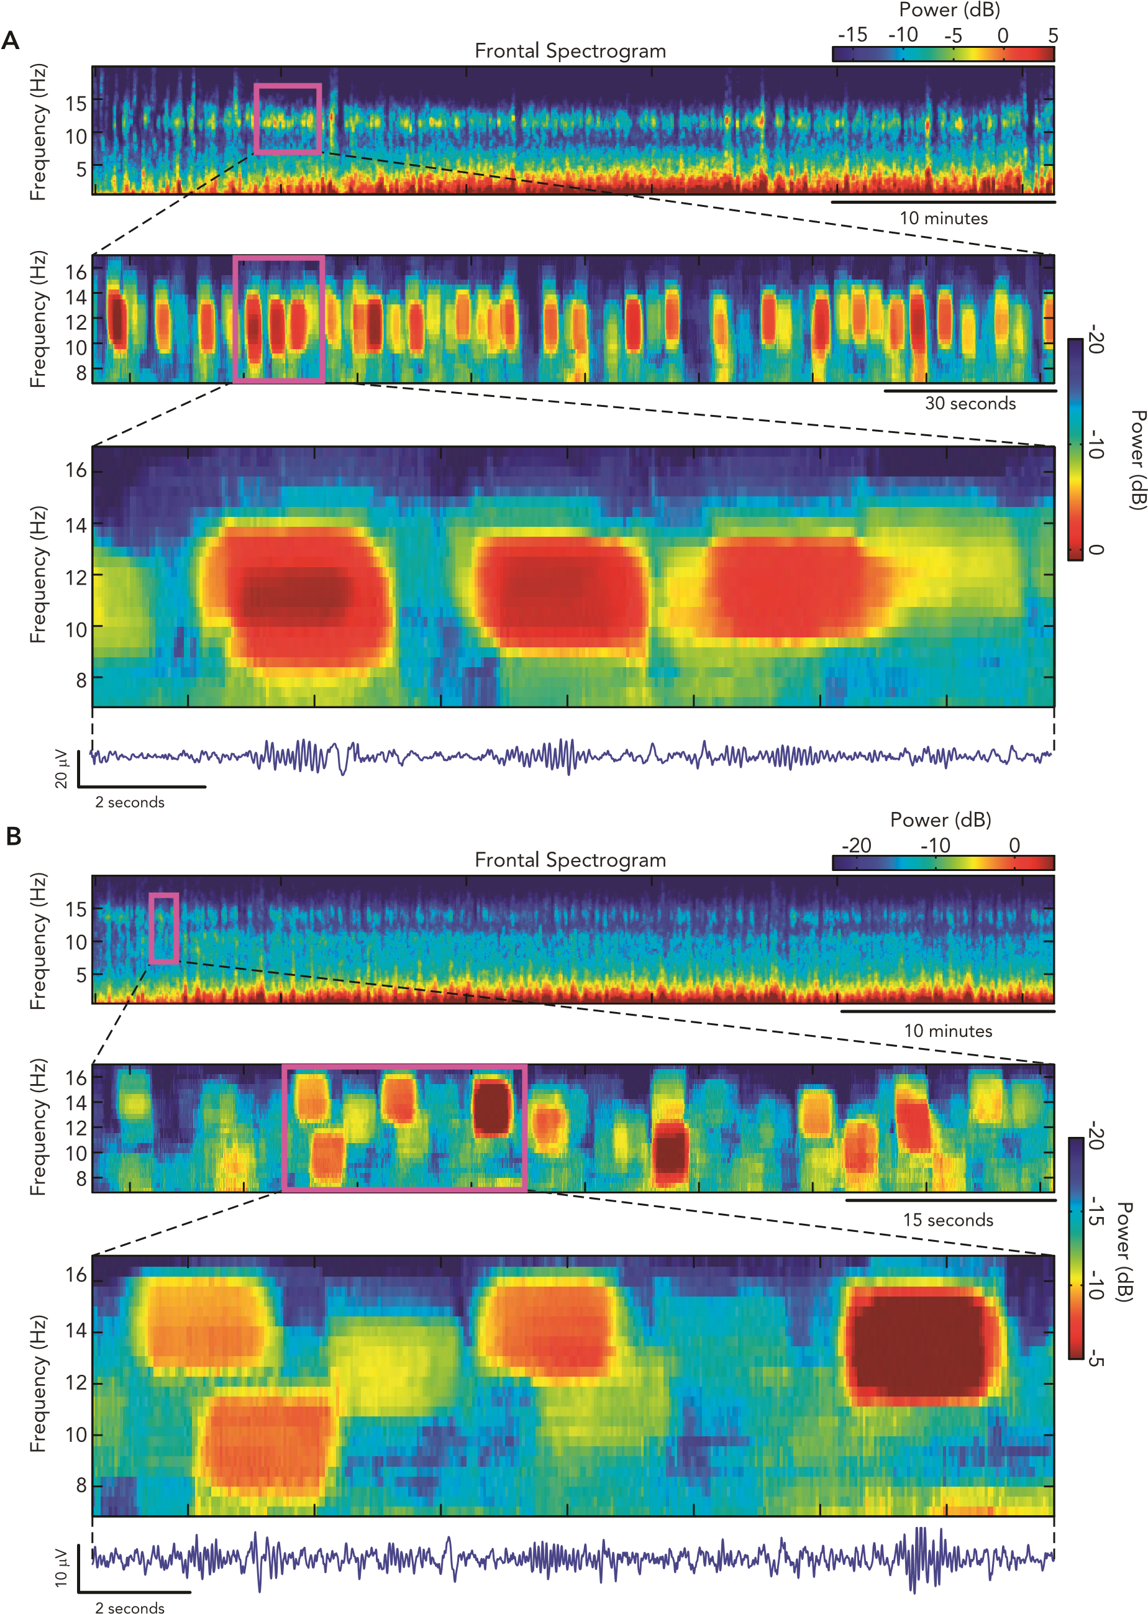
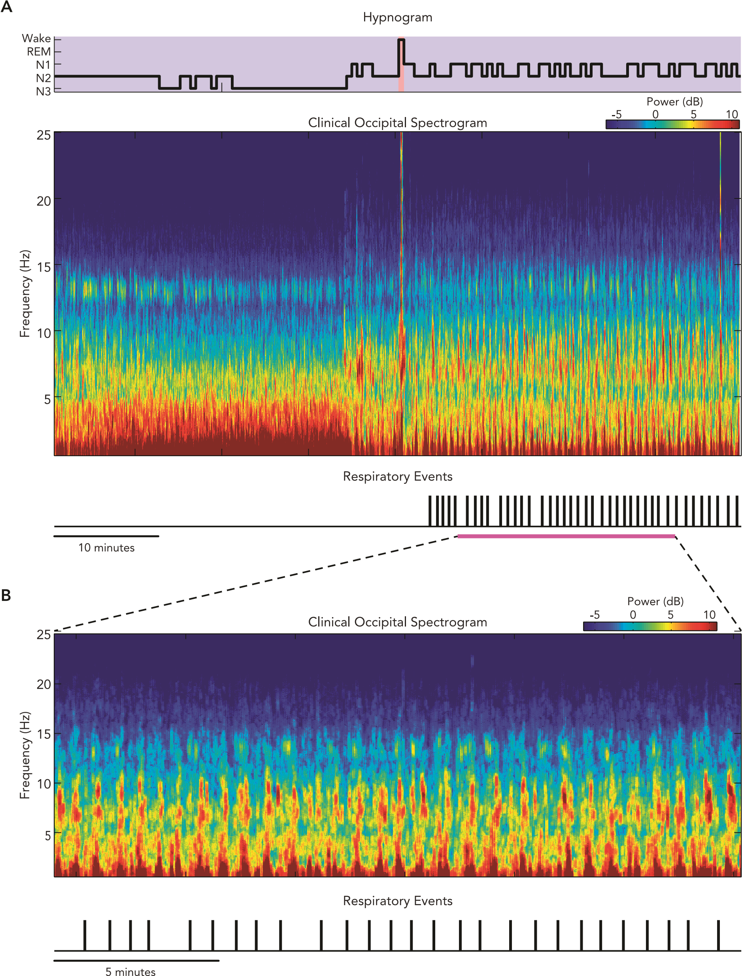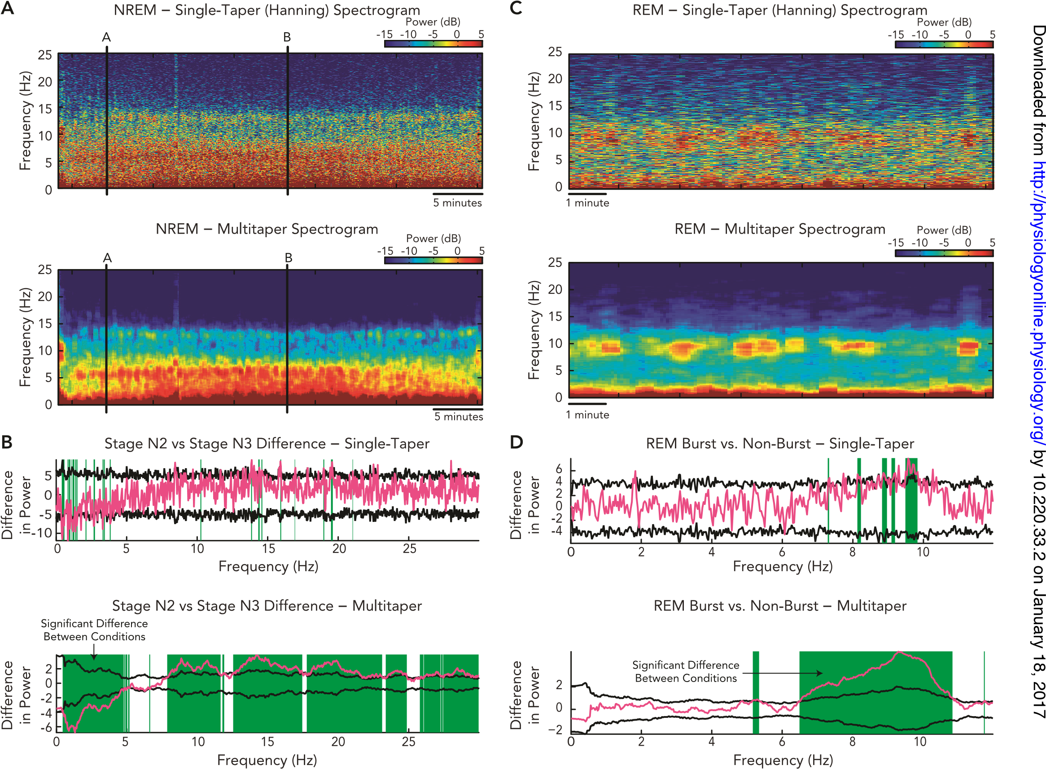

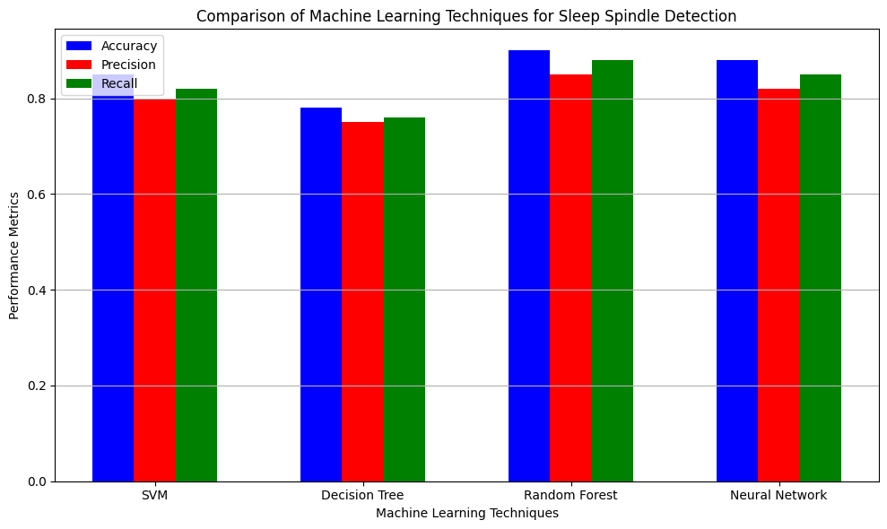
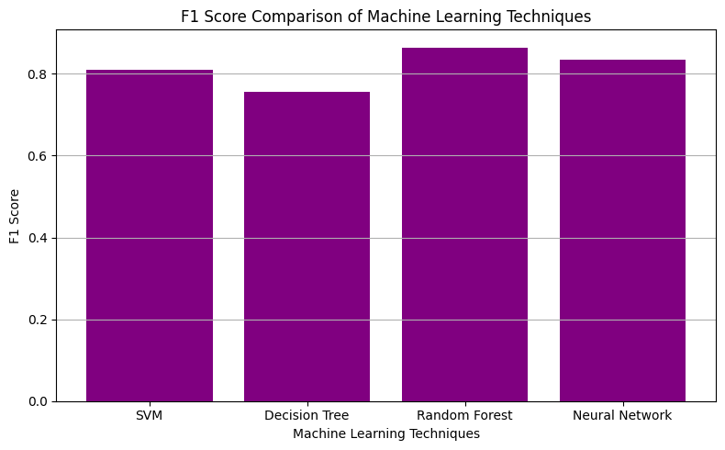

Best Technique based on Accuracy:
Technique Random Forest
Accuracy 0.9
Precision 0.85
Recall 0.88
Name: 2, dtype: object

Performance Metrics with F1 Score:
Technique Accuracy Precision Recall F1 Score
0 SVM 0.85 0.80 0.82 0.809877
1 Decision Tree 0.78 0.75 0.76 0.754967
2 Random Forest 0.90 0.85 0.88 0.864740
3 Neural Network 0.88 0.82 0.85 0.834731
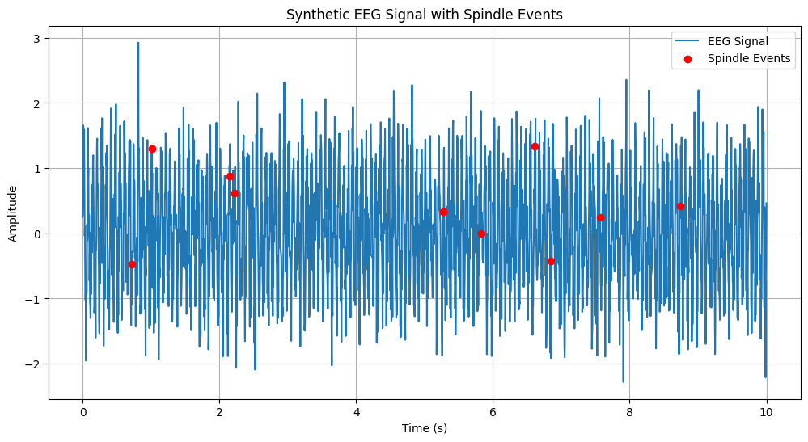
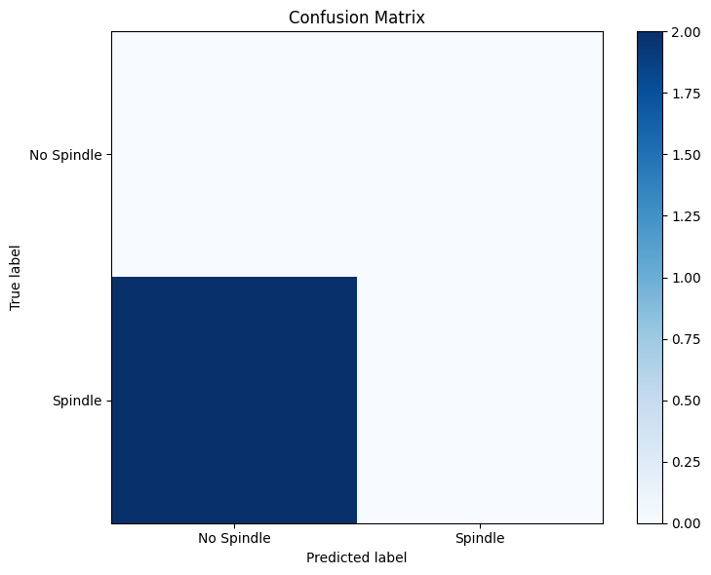
Classification Report:
precision recall f1-score support

0.0 0.00 0.00 0.00 0.0
1.0 0.00 0.00 0.00 2.0

accuracy 0.00 2.0
macro avg 0.00 0.00 0.00 2.0
weighted avg 0.00 0.00 0.00 2.0

